**Chapter 10**

**Statistical Inference About Means and Proportions**

**with Two Populations**

**Case Problem: Par, Inc.**

This case can provide discussion and differing opinions as to what hypothesis test should be conducted. Students should begin to see that logical arguments exist for structuring the hypotheses differently. In some interpretations of the problem, a two - tailed test can be appropriate for Par, Inc. In other interpretations of the same problem, a one - tailed test may be preferred. We suggest accepting different formulations of the Par, Inc. hypothesis test provided convincing rationale is provided.

Letting

**1 = population mean driving distance for the current golf ball

**2 = population mean driving distance for the new golf ball,

we suggest the following hypothesis test:

*H*0: **1 – **2  0

*Ha*: **1 – **2 > 0

This formulation is based on the information that the new golf ball is being designed to “resist cuts and yet still offer good driving distances.” The research hypothesis is not to prove the new golf ball out distances the current golf ball. In fact, Par could claim an improved quality with the cut resistance improvement provided the new golf ball has the same or better driving distance. The hypotheses have been structured so that rejection of *H0* corresponds to the conclusion that the new golf ball has the lower mean driving distances; this conclusion indicates that the cut resistance advantage may be offset by the loss of distance.

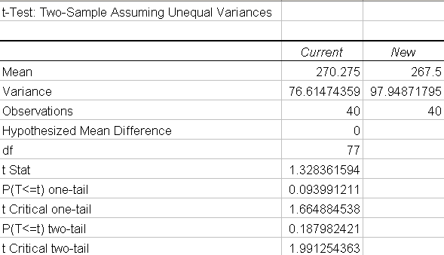

The sample mean for the current golf ball was 270.275 and the sample mean for the new golf ball was 267.50. On average, the current golf ball had a 2.775 yard advantage. Using the .05 level of significance, a *p*-value = 0.094 indicates *H*0 cannot be rejected. The data does not provide statistical evidence to conclude that the new golf ball has a lower mean driving distance than the current golf ball.

The argument should be made that in failing to reject *H0*, the research findings are inconclusive. While the data do not show the new golf ball with a significantly lower mean driving distance, the researcher should not be ready to conclude the mean distance for the new golf ball is equal to or better than the current golf ball. A potential for a Type II error exists with this conclusion. This is a case where continued study with more data should be relatively easy. With the mechanical hitting machine, samples of several hundred golf balls can be taken without much trouble. With more data, Par should have a good idea of the difference between the means for the two golf balls.